2nd June 2020
Dear parent or carer,
The governors and I are delighted to tell you about the appointment of a new head teacher for Trekenner Community Primary School.

After a very competitive process I am pleased to tell you that Mr Marc Wheeler will be taking up the post in September 2020. Mr Wheeler impressed us in a number of ways but particularly in his vision for the school and his commitment to the development of the whole child. He described some extremely imaginative and creative ways of working to continuing to improve standards without losing the friendly and close-knit elements of Trekenner that make it special.

Mr Wheeler currently works at Burraton School, Cornwall as an Assistant Head, managing Upper Junior staff (amounting to 11 staff) with a leadership responsibility for English, where he has been instrumental in leading change that's been recognised by the government at the highest level. He sits on the SLT at Burraton School and has worked across a number of other schools as a lead teacher enabling schools to improve particularly though not exclusively, in literacy. Marc will be teaching the year 5/6 children from September.

Mr Wheeler was also interviewed by the children at Trekenner as part of the process and although they were a little split along gender lines (we were lucky enough to also interview a really impressive female candidate), all of the children agreed that Mr Wheeler would bring great things to the school. He is very dedicated to children with additional needs and motivated to enable all children to reach their full potential.

This will be a new chapter for Trekenner CP School. I know that Mr Wheeler is really keen to meet the whole school community as soon as possible. He has been giving very careful thought to the impact of the pandemic and I know he will want to continue to ensure everyone’s safety from September onwards.

Very best wishes

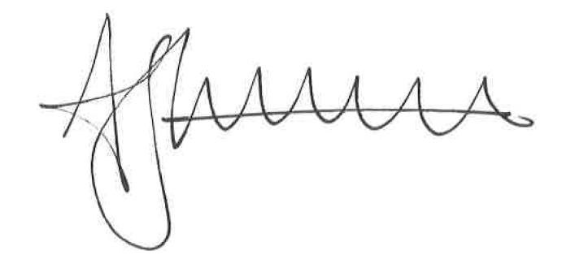

Mandy Precious,
Chair of Governors

